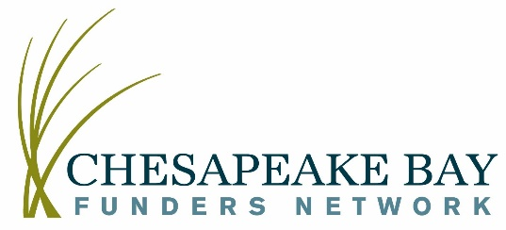

Seizing Market Opportunities to Support Soil Health
Date/Time: Thursday, October 29th 3:00PM – 4:30PM

Opportunities are emerging in our region and across the country that leverage market drivers to advance improvements in soil health, achieving multiple environmental and economic outcomes that can help bend regional food production toward sustainability and profitability. This program will feature a range of example initiatives, pilot programs and emerging ideas and serve as a primer for future conservations with the agriculture, conservation and local government communities in the Chesapeake Region about re-imagined approaches to funding, financing and paying farmers for on the ground conservation on our region’s farms.

3:00 PM | Welcome, Introductions via chat  Jamie Baxter, Chesapeake Bay Funders Network
3:05 PM | Panel and topic introduction  Alex Echols, Campbell Foundation for the Environment, moderator
3:15 PM | Monetizing soil and water outcomes  Adam Keil/Roger Wolf, Iowa Soybean Association, Soil and Water Outcomes Fund  Debbie Reed, Ecosystems Services Market Consortium, Voluntary water and carbon markets and potential Chesapeake Bay application
3:35 PM | Partnerships to achieve sustainability along the Supply Chain  Jenna Mitchell, Alliance for Chesapeake Bay, Clean Water Partnership  Lindsay Reames, MD and VA Milk Producers Cooperative Association
3:55 PM | New Market and Value Chain Development  Heather Coiner, Common Grain Alliance
4:05 PM | Question and Answer Session  Moderated by Alex Echols
4:30 PM | Wrap up and end program  Jamie Baxter, CBFN

To join this program, please register here in advance. After registering, Zoom will send a confirmation email with the call-in information.

