Want Clean Water? ACT!
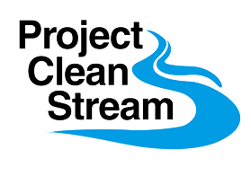 | Cape St. Claire  Saturday April 24th, 2021  9:00am – Noon  Get outside, volunteer for  a stream cleanup & make a  difference for your community.

Due to Covid restrictions, advance registration will be required. Go to CapeConservationCorps.org. Under Events find the link for Signup Genius and choose one of three starting points. Each will be limited to 25 persons. Masks required when in close proximity of others, and social distancing will be observed.
- Cape St. Claire Recreation Area Parking Lot (across the street from Graul’s)
- Deep Creek Marina (Cape stickers needed)
- Cape St. Claire Elementary School
Contact Brad Knopf – 443-324-1130 bdknopf@gmail.com
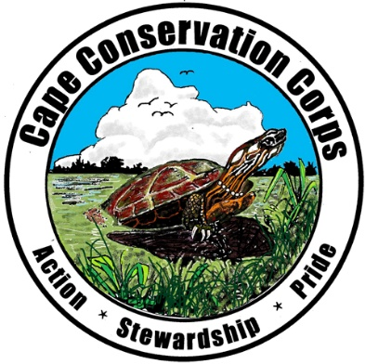
Gloves and trash bags provided. Trash will be collected and English Ivy removed
Bring a water bottle, and dress for a mess!
Rain Date Sunday April 25th 9am to Noon (Light rain won’t stop us!)

