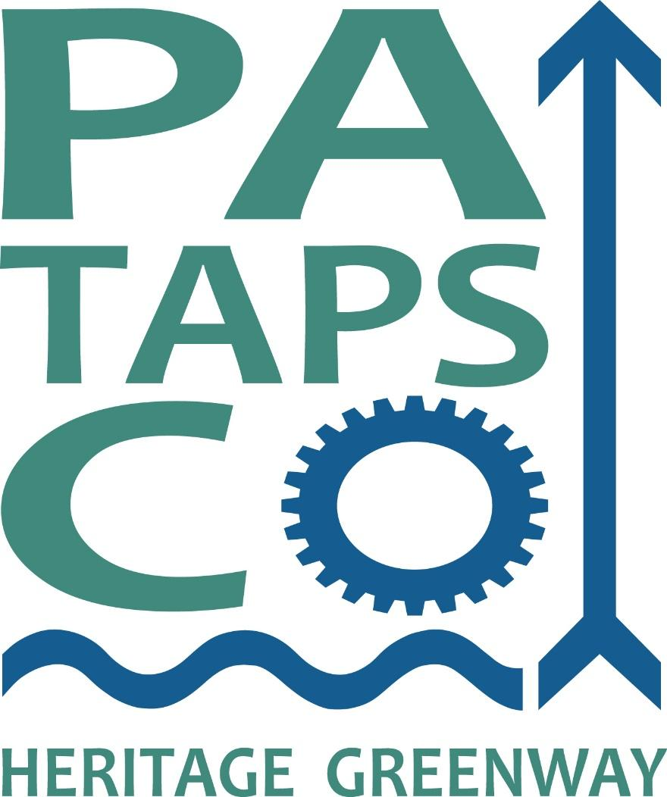
Environmental Program Manager, Patapsco Heritage Greenway

Patapsco Heritage Greenway’s (PHG) mission is to preserve, protect, interpret and restore the environment, history, and culture of the Patapsco Valley. We seek to reach our mission through a robust environmental stewardship program, expanding recreational opportunities, and managing the Patapsco Valley Heritage Area (PVHA), one of thirteen Maryland state heritage areas. We seek a full-time Environmental Program Manager to join our team, based in Ellicott City, Maryland.

The Environmental Program Manager oversees our environmental stewardship and environmental education programs and assists with other mission-driven programs and events. Job responsibilities include: managing staff and volunteers, developing citizen science initiatives, ensuring the success of volunteer-based stewardship programs including watershed cleanups, invasive species removals, tree plantings and maintenance, stream watch and water quality monitoring, managing communications for the environmental program, fostering and developing partnerships with non-profits, businesses and government agencies, and planning environmental education and ecotourism activities and events that connect with our heritage, recreation and arts/culture programs.
Minimum Qualifications: A BA/BS in a scientific field or comparable experience is required. A general understanding of water quality, stormwater and watershed health concepts. Excellent written, verbal and public communication skills. Motivated, flexible, problem solver with an ability to work as part of a team, with partners, and individually to complete projects in a timely manner. Candidates should have leadership experience, strong organizational and problem-solving skills, budgeting experience and familiarity with and/or interest in grant writing and reporting. We are looking for a good communicator familiar with using social media platforms and experience engaging a diverse community. A commitment to diversity, equity and inclusion is essential. We welcome candidates with fluency or proficiency in languages other than English.

Working for PHG:
This is a fulltime (40 hours/week), benefitted, salaried position, which requires some weekend and evening hours.

PHG focuses on creating a positive work environment and offers the following benefits with this position:
- Salary Range: $40,000-$45,000 depending on qualifications and experience.
- We provide an annual stipend to offset the cost of health insurance premiums.
- We offer a 401(k) plan and provide a cell phone stipend for staff who use their phone for work.
- We provide support for and encourage professional development opportunities, including trainings, conferences and networking events.
- We provide reimbursement for work-related travel expenses.
- During the current COVID-19 crisis, our team is working remotely, although we expect candidates to be located within driving distance of Ellicott City.
- We are a small organization and work hard to create a team atmosphere. Everyone is approachable, lines of communication are open, and we participate in regular team building exercises.
- Staff has access to a company vehicle for work events.

To Apply: Submit a cover letter, resume and list of 3 references to Aaron Shapiro, PHG Executive Director (director@patapsco.org) by 5 PM Eastern Time on May 10, 2021. If you have questions about the position, please feel free to email director@patapsco.org.

