CLWN HR Committee
Executive Director Search
Position Posting for Digital Media

POSITION AVAILABLE: EXECUTIVE DIRECTOR, NON-PROFIT
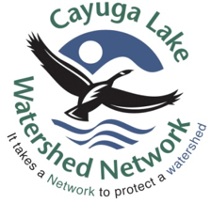
Are you passionate about water resources and climate change?
Looking for a career advocating for clean water and protecting our watershed?
Do you have experience in sustainability, water policy or environmental science?

The Cayuga Lake Watershed Network (CLWN) has begun the search for its new Executive Director to lead, administer and build upon its mission during this time of climate crisis.

The CLWN is a nonprofit 501(c)3 organization with offices at Wells College in Aurora, NY. The Network works to identify key threats to Cayuga Lake and its watershed, and advocates for solutions that support a healthy environment and vibrant, sustainable communities. Located in the beautiful Finger Lakes Region of central New York, the 860 square-mile watershed is comprised of parts of seven counties.

Following is a partial list of the required qualifications sought:
- Bachelor’s degree or higher in an environmentally related field plus relevant experience
- A proven record of securing grant funding
- Current or prospective residency within the watershed
- Experience interacting with a broad range of stakeholders, such as non-profit boards, local and state government agencies, land managers, business leaders, and others

Competitive salary and benefits package. Application deadline: September 30, 2021. Obtain the full position description, the full list of required and desired qualifications and the application information from the CLWN website at https://cayugalake.org.

