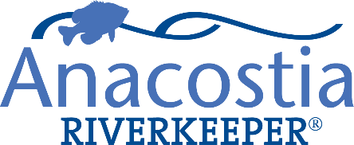

Communications Coordinator/Operations Manager– Part Time
The mission of Anacostia Riverkeeper is to protect and restore the Anacostia River for all who live, work, and play in the watershed, and to advocate for a clean, healthy river for all its communities. Anacostia Riverkeeper works in collaboration with local groups, legal counsel, federal and local government officials, foundations, and community members to ensure well-written environmental laws, enforcement of the existing laws, public awareness of environmental and health issues, and the cleanup and prevention of pollution of the river and its tributaries.
We are seeking a committed communications professional to help streamline and manage our outward facing communications to stakeholders and members as well as assist in managing day to day company operations. This position will help to shape our messaging and branding moving forward and will be integral to the growth of Anacostia Riverkeeper. The candidate will have broad experience in digital media, graphic design, content creation, and administrative work.
Job Duties
- Manage and curate content for all ARK social media channels
- Create and design ARK promotional materials (e.g., brochures, fact sheets, posters, handouts)
- Produce digital graphics for reports, fact sheets, and other outward facing materials
- Collect, input, and manage donor and volunteer information into ARK CRM software
- Produce and send electronic newsletters to donors and community members
- Assist in the scheduling of ARK programs. This includes boat tours (March to November), trash clean-ups, and other field programs.
- Update staff calendars
- Assist ARK Acting President in organizational operations tasks
Job Requirements
- Proficiency with Microsoft Office, Adobe Creative Suite (i.e., Illustrator, InDesign, etc.), Wordpress, and EventBrite
- There will be some weekend and weeknight work for some programs; Limited, but present email availability during weeknights and weekends during boat tour season (March – November)
- Ability to organize and manage large scheduling tasks
- Self-starter and autonomous worker, able to self-regulate available tasks
Preferred qualifications
- Non-profit experience; specifically those involving the environment or clean water
- Writing grants, reports, press releases, and other official documents
- Experience with integrating and maintaining CRMs
- Graphic design experience
- Strong commitment to structure, planning, and organization
This is a part-time 20 hr./wk. position. Remote option available but preference given to candidates who can come in person on occasion. Hourly pay at $25 per hour or commensurate with experience. Please submit resume and a cover letter via email to riverkeeper@anacostiariverkeeper.org by Oct 31. Applications will be evaluated on a rolling basis.

