Want Clean Water? ACT!
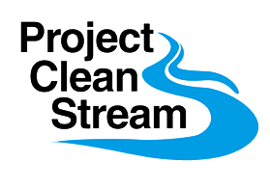 | Cape St. Claire  April 2nd, 2022  9:00am – Noon  Get outside, volunteer for  a stream cleanup & make a  difference for your community.

Cape St. Claire Recreation Area Parking Lot
Across the street from Graul’s
We will divide up into teams to work on several Cape locations
Volunteer to help make our Neighborhood cleaner & safer.
Contact Brad Knopf – 443-324-1130 bdknopf@gmail.com
Cape Conservation Corps
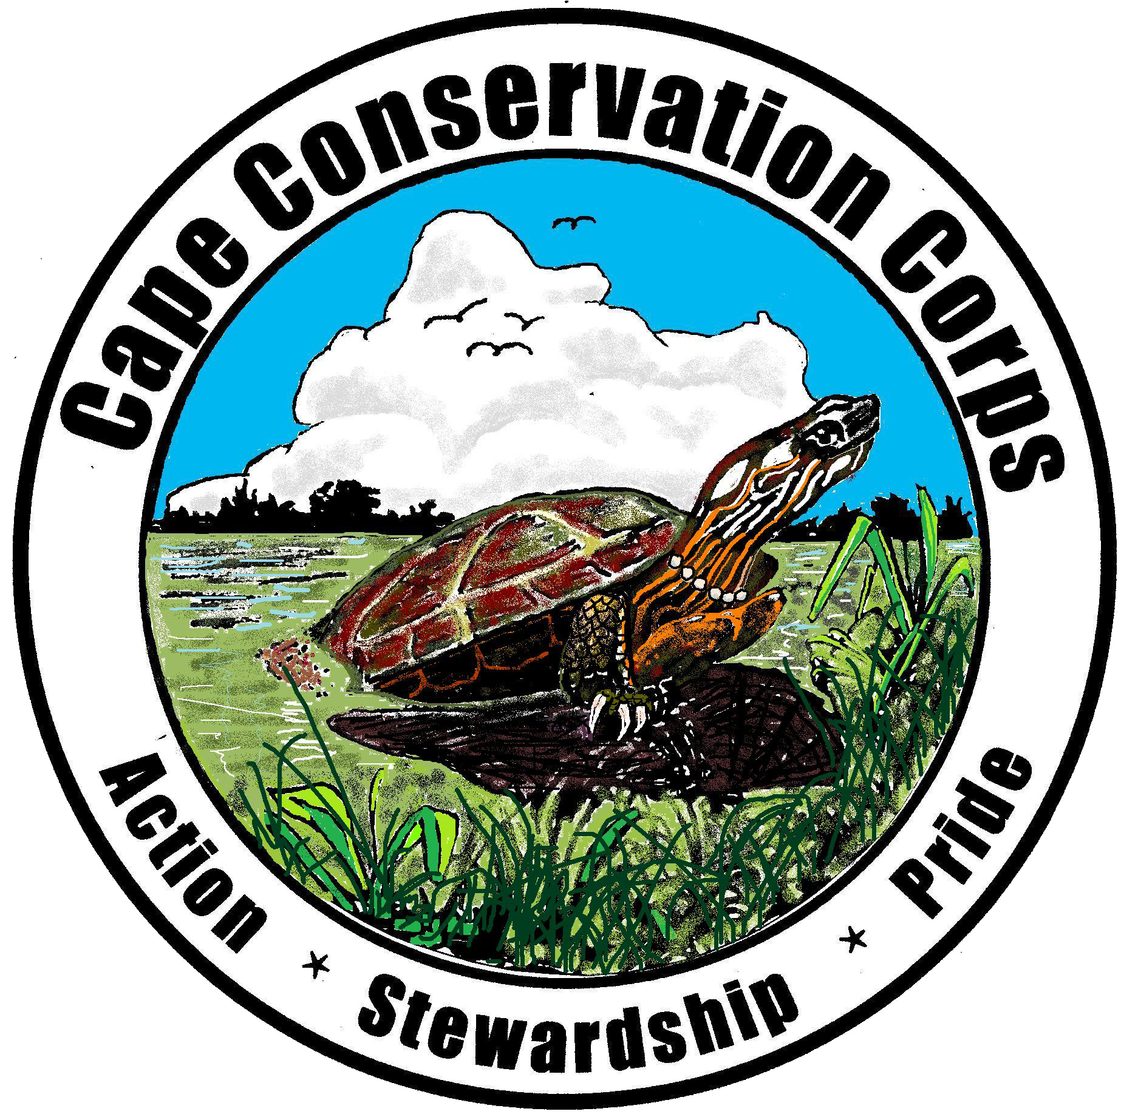

Wear boots or sturdy shoes, outdoor clothing you don’t mind getting dirty, and bring a water bottle

