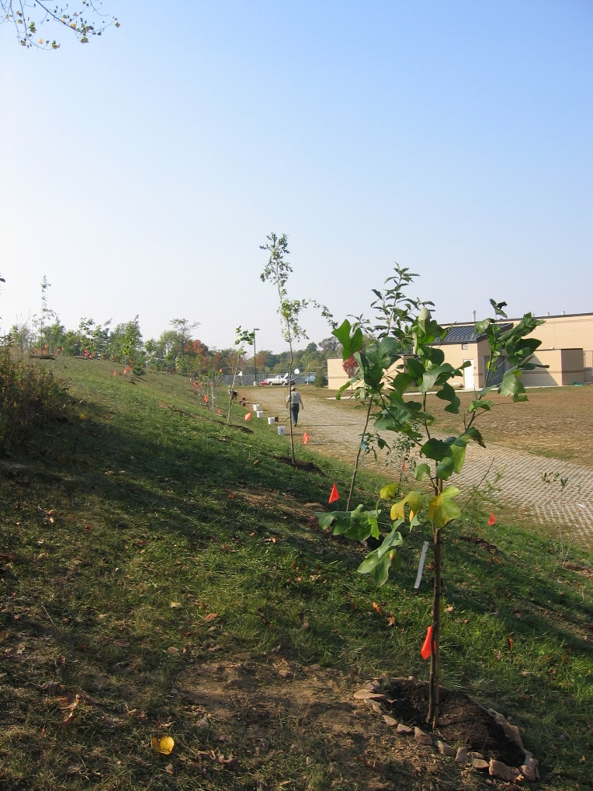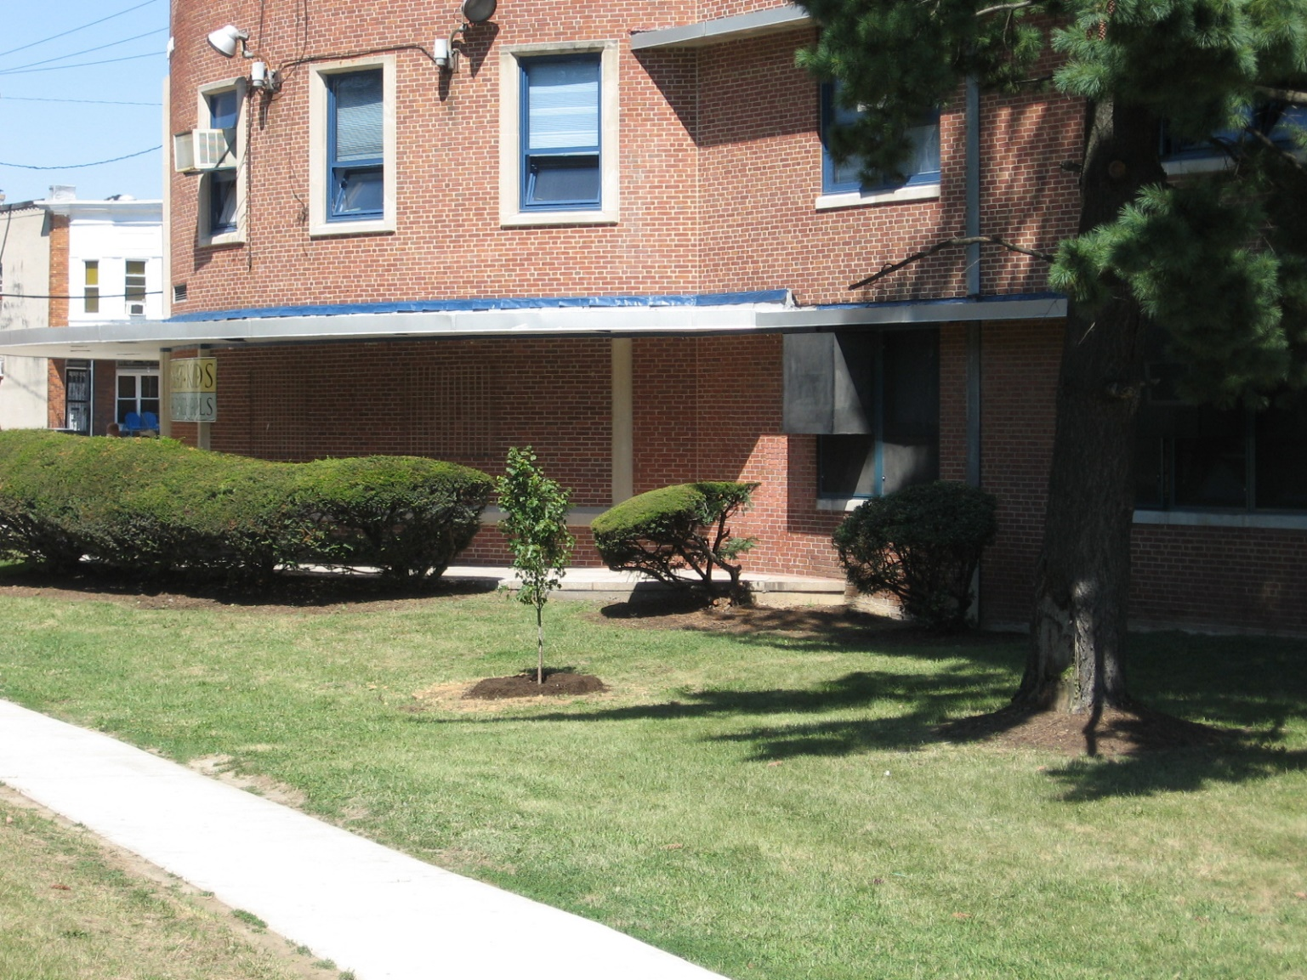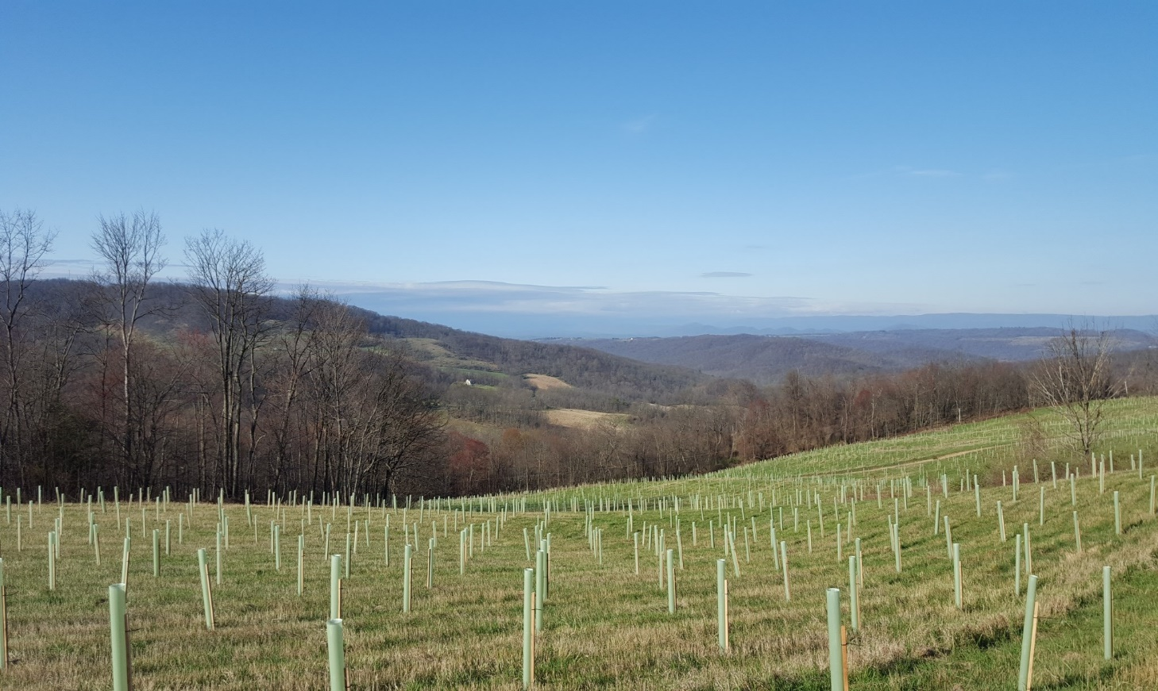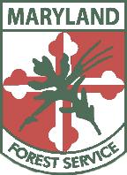DNR_logo_final_small.png

Be part of the 5 million treE movement & join the mARYLAND forest service!

*13 open positions COMING SOON!*

Scan this QR code to fill out a contact card!

**here’s your chance to jump into a natural resources career**

In a quest to plant **5 million trees** over 9 years for the Tree Solutions Now Act of 2021, the MD Department of Natural Resources Forest Service is looking for a diversity of talent to help our cities and communities get thousands of trees in the ground. Positions are available across the state in rural and urban settings.

Work will include outreach, planning, working with volunteers and other groups, tree planting, tree maintenance and survival assessments, and tree seed collection/ tree nursery assistance. We are looking for individuals with enthusiasm for nature-based solutions for communities of all sizes.

Tree identification and planting training will be provided to the 5 Million Trees Team!

REPLY >> [JOIN5MTTeam.DNR@maryland.gov](file:///\\dnr-nas.langroup.dnr.md\departments\Forestry\5MillionTrees\Fliers\JOIN5MTTeam.DNR@maryland.gov)

SEARCH >> “state of Maryland job openings”

VISIT >> https://jobapscloud.com/MD