Virginia Director of Land Management

Who We Are:
The Nature Conservancy’s mission is to protect the lands and waters upon which all life depends. As a science-based organization, we create innovative, on-the-ground solutions to our world’s toughest challenges so that we can create a world in which people and nature thrive. We’re rooted in our Mission and guided by our Values, which includes a Commitment to Diversity and Respect for People, Communities, and Cultures. Whether it’s career development, flexible schedules, or a rewarding mission, there’s lots of reasons to love life #insideTNC. Want a better insight to TNC? Check out our TNC Talent playlist on YouTube or on Glassdoor.
Our goal is to cultivate an inclusive work environment so that all our colleagues around the globe feel a sense of belonging, and that their unique contributions to our mission are valued. We know we’ll only achieve our Mission by hiring and engaging a diverse workforce that reflects the communities in which we work. In addition to the requirements in our postings, we recognize that people come with talent and experiences outside of a job. Diversity of experience and skills combined with passion is a key to innovation and a culture of inclusion! Please apply – we’d love to hear from you. To quote myriad TNC staff members, “you’ll join for our mission, and you’ll stay for our people.”

What We Can Achieve Together:
The Virginia Director of Land Management (DLM) works collaboratively with other Virginia Chapter staff-as well as private landowners, natural resource agencies, tribes, and other partners where appropriate-to establish and execute a vision for preserve management, visitation, conservation easement monitoring, and volunteer engagement to advance organizational goals. This includes work on the preserve disposition process to divest non-strategic fee and easement assets, active participation in our mature, state-wide prescribed fire program, and oversight of the Chapter’s participation in TNC’s overall accreditation by the Land Trust Alliance. They provide science review and approve stewardship budgets for new land protection projects along with the terms of conservation easements. They develop and manage annual budgets and work to secure needed resources for stewardship activities. The DLM provides direct supervision to several stewardship staff. They cultivate a collaborative, inclusive and trusting team environment. They ensure central stewardship staff feel connected to the broader Chapter, and work closely with the Deputy Director and others to ensure stewardship is appropriately considered and reflected in Chapter plans and priorities. They directly engage in land management activities, including prescribed fire, and support the coordination of engagement strategies to preserve-based stewardship efforts. The DLM works closely with other staff to ensure all monitoring and related obligations are met in a timely fashion.

We’re Looking for You:
- They will work closely with the Deputy Director, Director of Landscape Conservation, and program managers to achieve integration of central stewardship and landscape programs.
- They manage staff with responsibility for performance management, training and development.
- They delegate responsibility and authority to staff and clearly define expectations. Establishes clear directions and sets stretch objectives.
- They oversee maintenance and management of stewardship team’s vehicle and equipment cache.
- Set and meet programmatic goals and objectives in ways that support equitable outcomes.
- Work closely with finance, grants and philanthropy teams to identify, secure and manage operating funds from private and public sources.
- Practice analytical, strategic and systems-level thinking.
- Lead and manage team to support and improve conservation efforts.
- Establish and maintain optimal standards of performance for the program while controlling costs and administering budgets.
- Responsible for ensuring that public and private funds are raised to meet program needs.
- Build cooperation from outside parties to accomplish program goals
- May work in variable weather conditions, at remote locations, on difficult and hazardous terrain and under physically demanding circumstances.
- Frequently make independent decision based on analysis, experience, and context

What You’ll Bring:
- BA/BS degree and 5 years’ experience in conservation practice or equivalent combination of education and experience.
- Experience managing complex or multiple projects, including staffing, workloads and finances under deadlines.
- Supervisory experience, including motivating, leading, setting objectives and managing performance.
- Experience in partnership development with non-profit partners, community groups and/or government agencies
- Experience in prescribed burning, including the ability to pass an arduous pack test within six months of starting employment
- Familiarity with principles of ecological management
- Experience using applications such as Microsoft Word, Excel, ArcGIS.
- Experience negotiating.

DESIRED QUALIFICATIONS
- 5-7 years’ experience in conservation practice or related field or equivalent combination of education and experience.
- Demonstrated experience influencing, developing and implementing conservation policy and plans.
- Knowledge of current trends and practices in conservation, land management, and natural resource management.
- Knowledge of methods and standards of biodiversity information systems and initiatives or related field.
- Communicating clearly via written, spoken, and graphical means in English and other relevant languages.
- Demonstrated experience in fundraising.
- Politically savvy.

What We Bring:
Since 1951, The Nature Conservancy has been doing work you can believe in protecting the lands and waters that all life depends on. Through grassroots action, TNC has grown to become one of the most effective and wide-reaching environmental organizations in the world. Thanks to more than 1 million members, over 400 scientists, and the dedicated efforts of our diverse staff, we impact conservation throughout the world!

The Nature Conservancy offers a competitive, comprehensive benefits package including: health care benefits, flexible spending accounts, 401(k) plan including employer match, parental leave, accrued paid time off, life insurance, disability coverage, employee assistance program, other life and work wellbeing benefits. Learn more about our benefits at in the Culture Tab on nature.org/careers.

We’re proud to offer a work-environment that is supportive of the health, wellbeing, and flexibility needs of the people we employ!

This description is not designed to be a complete list of all duties and responsibilities required for this job.

TO APPLY:
Go to www.nature.org/careers, click Current Job Opportunities and search by the position title and/or location, then click Apply Now to submit an online application. The Job ID for the Virginia Director of Land Management is 53008. It is necessary to complete the application in its entirety. In addition, please attach as one document your resume and a letter of interest. For assistance with the online process, go to:
http://www.nature.org/aboutus/careers/external-applicant-userguide.pdf.
Interested TNC employees should apply through PeopleSoft: https://peoplesoft.tnc.org/psp/tnchrprd/?cmd=login&errorPg=ckreq&languageCd=ENG
Application deadline is 11:59 PM on March 19, 2023.

Our Competencies:
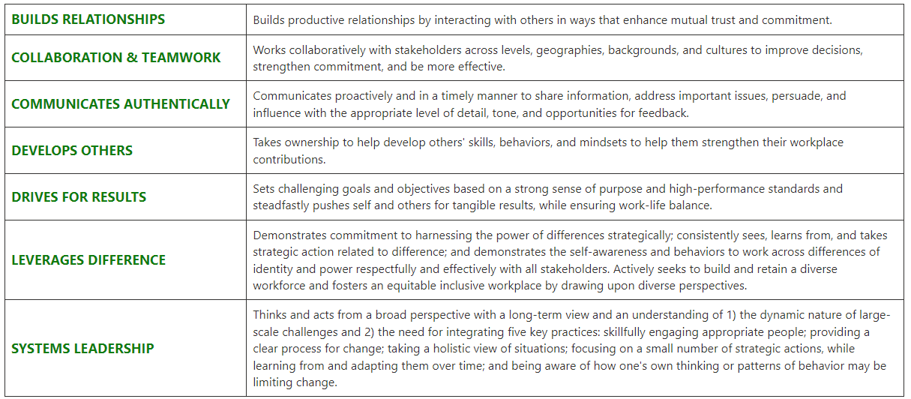

The Nature Conservancy is an Equal Opportunity Employer. Our commitment to diversity includes the recognition that our conservation mission is best advanced by the leadership and contributions of people of diverse backgrounds, beliefs, and cultures. Recruiting and mentoring staff to create an inclusive organization that reflects our global character is a priority and we encourage applicants from all cultures, races, colors, religions, sexes, national or regional origins, ages, disability status, sexual orientations, gender identities, military, protected veteran status or other status protected by law.
TNC is committed to offering accommodations for qualified individuals with disabilities and disabled veterans in our job application process. If you need assistance or an accommodation due to a disability, please send a note to applyhelp@tnc.org with Request for Accommodation in the subject line.

